Geometry: Unit 10, Lesson 5
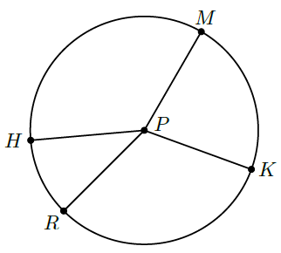
- Circle $P$ is shown, where points $M$, $K$, $R$, and $H$ are on the circle. What arc is intercepted by $∠RPK$?

$$\hat{KR}$$

- What is the value of the expression $\left(17y-13\right)-(11y+3)$ if $y=8$?

$$x=32$$
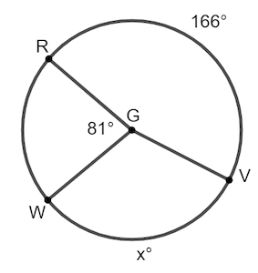
- Circle $G$ is shown, where points $R$, $V$, and $W$ lie on the circle, $m \hat{RV}=166°$, $m \hat{WV}=x°$, and $∠RGW=81°$. What equation can be used to find the value of $x$?

$$81+166+x=360$$

